Software Design Document
<MENTAL HEALTH TRACKER>



Submitted by
<Sawera Shahzadi (F24BINFT07M04031)>

Submitted to
<Dr. Muhammad Asadullah >

Department of Information Technology
Faculty of Computing
The Islamia University of Bahawalpur
Summery
The Mental Health Tracker System is a web-based application designed to help individuals monitor and manage their mental health effectively. The system allows users to register, log in, record daily mental health indicators such as mood, stress level, and sleep patterns, and view progress reports over time. Healthcare professionals or administrators can monitor user data to support early detection and intervention. The system is developed using Python for backend processing, HTML for web page structure and CSS for user interface design. Three-tier architecture is used, consisting of the presentation layer, application layer, and data layer, ensuring modularity, scalability, and ease of maintenance. The Waterfall software process model is adopted due to clearly defined requirements. The design includes standard UML and system models such as class diagrams, sequence diagrams, state transition diagrams, and data flow diagrams (DFD) to clearly represent system structure and behavior. A secure data design ensures confidentiality of sensitive mental health information, supported by authentication and encrypted data storage. Core algorithms handle user registration, login, data validation, mental health data entry, and report generation. These algorithms work together to provide a smooth and secure user experience. The Human Interface Design focuses on simplicity and usability, providing intuitive screens for login, mood entry, dashboards, and administration. A Software Requirements Traceability Matrix (SRTM) ensures all functional requirements are properly implemented and verified. Overall, the Mental Health Tracker System provides a reliable, user-friendly, and secure solution for mental health monitoring, supporting both users and healthcare professionals.

Table of Content
1. Introduction……………………………………………………………………………………….5
2. Design Methodology 5
3. Software Process Model 6
4. System Overview 7
4.1 Architectural Design 7
4.2 Process Flow / Representation 8
5. Design Models 10
5.1 Class Diagram 10
5.2 Sequence Diagram 12
5.3 State Transition Diagram 12
5.4 Data Flow Diagram (DFD) 14
6. Data Design 15
6.1 Data Dictionary 15
7. Algorithms and Implementation 15
How These Algorithms Work Together 17
8. Software Requirements Traceability Matrix 18
9. Human Interface Design 18
9.1 Screen Image 18
9.2 Screen Objects and Actions 19
10. References 20

List of Figures

Fig 4.1 Video Surveillance Process…………………………………….9

Fig 5.1 Class Diagram for IVSS……………………………………...11

Fig 5.2 Sequence Diagram for IVSS………………………………....12

Fig 5.3 State Transition Diagram……………………………………..13

Fig 5.4 Data Flow Diagram……………………………………………14

Fig 7.1 How IVSS Algorithms Work Together………………………17

Revision History

Name | Date | Reason for changes | Version

Application Evaluation History

Comments (by committee)  *include the ones given at scope time both in doc and presentation | Action Taken

Supervised by
Dr.AsadUllah
Signature: ____________

1. Application Architecture
The Mental Health Tracker system follows a three-tier web application architecture, which separates the system into independent layers. This architecture improves security, scalability, and maintainability.

1. Presentation Layer (User Interface Layer)
Technologies: HTML, CSS
This layer is responsible for user interaction.
It includes:
- Login and registration pages
- Mood and mental health data entry forms
- Dashboard to view progress and reports
HTML provides the structure of the web pages, while CSS is used for layout, colors, and design. This layer only displays data and sends user input to the backend; it does not process business logic.

2. Application Layer (Business Logic Layer)
Technology: Python (Flask or Django)
This is the core layer of the system. It handles:
- User authentication and authorization
- Validation of mental health data
- Processing mood, stress, and sleep inputs
- Generating reports and feedback
When a user submits data from the UI, this layer processes the request, applies rules, and communicates with the database.

3. Data Layer (Database Layer)
Technology: SQLite / MySQL
This layer is responsible for secure data storage.
It stores:
- User profiles and login credentials
- Daily mental health records
- Historical mood and progress data
Only the application layer can access this database, ensuring data privacy and security.
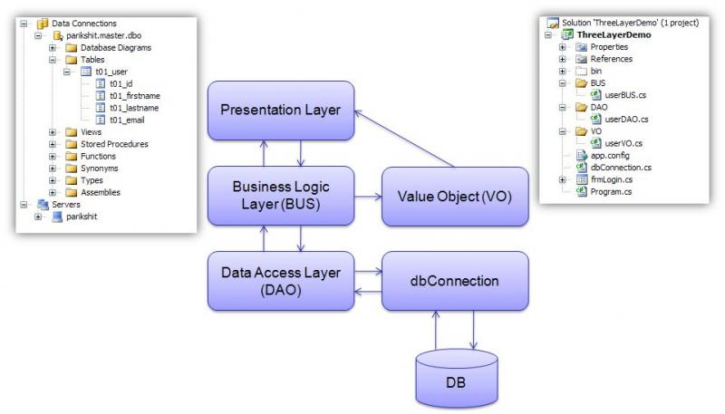

Data layer (Database layer)

- Data Model Schema
The data model defines how data is stored, organized, and related in the Mental Health Tracker system. The database is designed to store user information and daily mental health records securely.
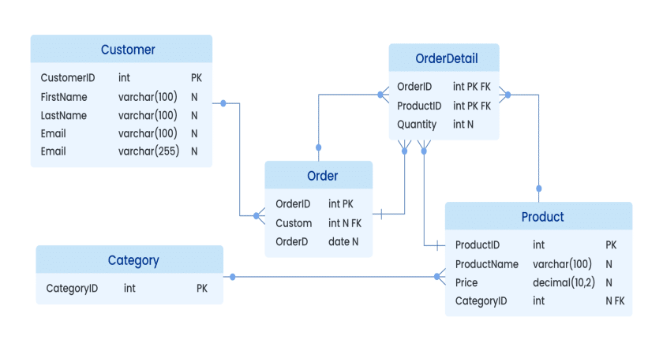

Data module schema diagram

Main Database Tables

1. User Table
This table stores basic user account information.
Field Name | Data Type | Description
user_id | Integer (PK) | Unique ID for each user
full_name | Varchar | User’s full name
email | Varchar | User email (unique)
password | Varchar | Encrypted password
role | Varchar | User role (User/Admin/Doctor)
created_at | DateTime | Account creation date
Purpose:
Used for user authentication and access control.

2. Mental_Health_Record Table
This table stores daily mental health tracking data.
Field Name | Data Type | Description
record_id | Integer (PK) | Unique record ID
user_id | Integer (FK) | References User
mood | Varchar | ( Happy ,sad)
stress level | Integer | stress scale (1–10)
sleep hours | Float | Hours of sleep
notes | Text | Optional user comments
record_date | Date | Date of entry
Purpose:
Tracks daily mental health status for each user.

3. Appointment / Review Table (Optional)
This table is used when doctors or admins review user data.
Field Name | Data Type | Description
review_id | Integer (PK) | Review record ID
user_id | Integer (FK) | Related user
doctor_id | Integer | Doctor/Admin ID
feedback | Text | Professional feedback
review date | Date | Date of review
Purpose:
Stores feedback and observations by healthcare professionals.

Relationships between Tables
- User → Mental_Health_Record
  - One user can have many mental health records
- User → Review
  - One user can receive multiple reviews
This is a one-to-many relationship.
3. User Interface

1. Login Interface
- Allows users to enter email and password
- Includes login and sign-up buttons
- Displays error messages for invalid credentials
Purpose: Secure access to the system

2. Registration Interface
- Collects user details such as name, email, and password
- Uses form validation for correct input
- Simple layout to avoid user confusion
Purpose: Create a new user account

3. Dashboard Interface
- Displays user summary and mental health overview
- Shows mood trends, stress levels, and recent activity
- Provides navigation to other pages
Purpose: Central screen for monitoring mental health status

4. Mental Health Data Entry Interface
- Includes dropdowns and sliders for mood and stress levels
- Text fields for notes or feelings
- Submit button to save daily record
Purpose: Allow users to record daily mental health data

5. Progress & Report Interface
- Displays graphs and summaries of past records
- Shows weekly or monthly mental health trends
Purpose: Help users understand changes in mental health over time

6. Admin / Doctor Interface
- Displays list of users
- Allows viewing of user mental health records
- Restricted access for authorized roles
Purpose: Monitoring and support by professionals

7. UI Design Principles Used
- Calm color scheme (light blue, green)
- Clear fonts and readable text
- Simple navigation menus
- Responsive layout for different devices

1. Introduction
The Mental Health Tracker System is a web-based application designed to help users monitor, record, and analyze their mental health status over time. The system allows users to register, log in, record daily mood and mental health data, and view progress reports. Healthcare professionals (doctors/admins) can monitor user data for early detection of mental health issues.
The system is developed using Python for backend processing, HTML for structure and CSS for styling and user interface design. This document describes the complete software design of the system.

2. Design Methodology
The system follows a modular and user-centered design methodology. Each module is designed independently and integrated later. The methodology focuses on:
- Clear separation of front-end and back-end
- Security and privacy of sensitive mental health data
- Ease of use for non-technical users
- Scalability for future enhancements

3. Software Process Model
The Waterfall Software Process Model is used for this project. The phases include:
- Requirement Analysis
- System Design
- Implementation (Python, HTML, CSS)
- Testing
- Deployment and Maintenance
This model is suitable because the requirements are well-defined and unlikely to change frequently.

4. System Overview
The Mental Health Tracker System is a client-server based web application. Users interact with the system through a web browser, while the backend server processes requests and stores data securely.

Key Features
- User Registration and Login
- Daily Mood Tracking
- Mental Health Questionnaire
- Progress Visualization
- Admin/Doctor Monitoring

4.1 Architectural Design
The system uses a Three-Tier Architecture:
- Presentation Layer
  - HTML (structure)
  - CSS (design and layout)
- Application Layer
  - Python (Flask/Django)
  - Handles business logic, validation, and processing
- Data Layer
  - SQLite/MySQL database
  - Stores user and mental health records

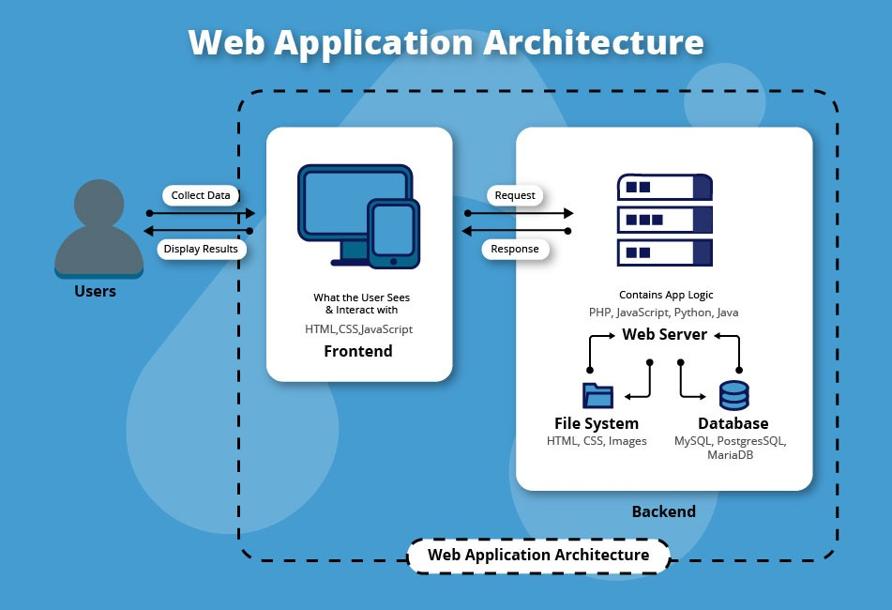

Diagram of architecture design

4.2 Process Flow / Representation
- User opens the web application
- User registers or logs in
- System authenticates the user
- User submits daily mental health data
- Python backend processes and stores data
- System displays progress and feedback

5. Design Models

5.1 Class Diagram
Main Classes:
- User
- Admin
- MentalHealthRecord
- Authentication
- DatabaseManager
Each class contains attributes (data) and methods (functions) relevant to its role.

5.2 Sequence Diagram
The sequence of interactions is: User → Web Browser → Python Server → Database → Python Server → Web Browser → User

5.3 State Transition Diagram
System States:
- Start
- User Registration
- Login
- Data Entry
- Data Analysis
- Logout
The system transitions between these states based on user actions.

5.4 Data Flow Diagram (DFD)
Level 0 DFD (Context Diagram):
- External Entity: User / Doctor
- Process: Mental Health Tracker System
- Data Store: Mental Health Database
Level 1 DFD:
- User Authentication
- Data Collection
- Data Storage
- Data Reporting

6. Data Design
The database is designed to securely store sensitive mental health information with proper access control.

6.1 Data Dictionary
Field Name | Data Type | Description
user_id | Integer | Unique user identifier
name | String | User full name
email | String | User email address
password | String | Encrypted password
mood | String | User mood level
stress level | Integer | Stress score (1–10)
sleep hours | Float | Hours of sleep
date | Date | Record date

Data Dictionary Diagram (Logical View)
USER
├── user_id (Integer, PK)
├── name (Varchar)
├── Email (Varchar, Unique)
├── Password (Varchar, Encrypted)
├── Role (Varchar)
└── created_at (DateTime)

MENTAL_HEALTH_RECORD
├── record_id (Integer, PK)
├── user_id (Integer, FK)
├── Mood (Varchar)
├── stress_level (Integer)
├── anxiety_level (Integer)
├── sleep_hours (Float)
├── notes (Text)
└── record_date (Date)

QUESTIONNAIRE
├── question_id (Integer, PK)
├── question text (Text)
└── Category (Varchar)

RESPONSE
├── response_id (Integer, PK)
├── user_id (Integer, FK)
├── question_id (Integer, FK)
├── answer (Varchar)
└── Response date (Date)

APPOINTMENT
├── appointment_id (Integer, PK)
├── user_id (Integer, FK)
├── doctor_id (Integer, FK)
├── Appointment date (Date)
└── Status (Varchar)

7. Algorithms and Implementation

Algorithm 1: User Registration
- Receive user details
- Validate input data
- Encrypt password
- Store data in database

Algorithm 2: User Login
- Receive credentials
- Validate credentials
- Grant access or display error

Algorithm 3: Mental Health Data Entry
- Accept daily mental health input
- Validate input
- Store record in database
- Update progress dashboard

1. Overall Implementation Diagram (System Flow)
User
|
V
Web Browser (HTML / CSS UI)
|
V
Python Backend (Flask / Django)
|
|-- Authentication Module
|-- Mental Health Processing Module
|-- Report Generation Module
|
V
Database (Users, Records, Reports)
|
V
Python Backend
|
V
Web Browser (Dashboard / Results)

Explanation:
- User interacts with the UI
- Python backend processes requests
- Data is stored and retrieved from database
- Results are shown to the user

2. Algorithm 1: User Registration (Flow Diagram)
Start
|
Enter User Details
|
Validate Input?
|---No---> Show Error Message ---> End
|
Yes
|
Encrypt Password
|
Store User in Database
|
Show Registration Success
|
End
3. Algorithm 2: User Login (Flow Diagram)
Start
|
Open Data Entry Form
|
Enter Mood, Stress, Sleep
|
Validate Data
|---Invalid---> Error Message ---> End
|
Valid
|
Save Record to Database
|
Update Dashboard
|
End

Algorithm 2: User Login (Flow Diagram)
Start
|
Enter Mood, Stress, Sleep
|
Validate Data
|---Invalid---> Error Message ---> End
|
Valid
|
Save Record to Database
|
Update Dashboard
|
End

5. Algorithm 4: Report Generation Algorithm
Start
|
Fetch User Records
|
Analyze Mood & Stress Trends
|
Generate Summary Report
|
Display Graphs & Feedback
|
End

6. How Algorithms Are Implemented Together
Login Algorithm
|
V
Authentication Success
|
V
Data Entry Algorithm
|
V
Database Storage
|
V
Report Generation Algorithm
|
V
User Dashboard Output

How These Algorithms Work Together
User authentication ensures secure access. Once logged in, the data entry algorithm collects daily mental health data. Stored data is then used by reporting algorithms to generate insights and progress reports. All algorithms share common validation and database modules.

8. Software Requirements Traceability Matrix
Requirement ID | Description | Module
FR001 | User Registration | Authentication
FR002 | User Login | Authentication
FR003 | Mood Tracking | Mental Health Module
FR004 | Data Storage | Database
FR005 | Report Generation | Dashboard

9. Human Interface Design

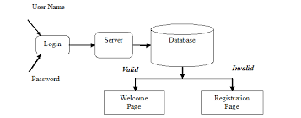

Diagram of human Interface

9.1 Screen Image
Main system screens include:
- Login Screen
- Registration Screen
- Mood Entry Screen
- Dashboard Screen
- Admin Panel

9.2 Screen Objects and Actions
Screen Object | Action
Text Box | Enter data
Button | Submit information
Dropdown | Select mood
Graph | Display progress

10. References
- Ian Sommerville, Software Engineering
- Python Official Documentation
- Flask / Django Documentation
- W3Schools HTML & CSS Tutorials
- WHO Mental Health Resources

Healthcare & Mental Health Systems
6. World Health Organization (WHO) – Mental Health Resources
👉 Authoritative reference for mental health concepts and data types
7. Health Information Systems: Concepts and Technology
👉 Useful for understanding healthcare data systems

